Note: Include this page only when adding / amending / deleting a document. If using this document as a record, this Revision History page can be omitted.

REVISION HISTORY

Revision no | Date | Description of Changes | Reason for Revision | Revised by | Approvedby
1 | 19 Apr 13 | - Add revision history page | - Recommendation from Stage 2 audit | RDPlacido
2 | 11 Dec 15 | - Added Disclaimer  - Include in the notes the schedule of reporting of the Survey Results  - Changed the first step since the Client Satisfaction Survey is done according to schedule | - Printing is sole responsibility of the person who printed it  - Additional information  - Schedule depends on the account. | RCGanal | ECVentura

- Objective

To measure the clients’ perception on how well the company delivers its solutions and services.

To use the survey results as inputs to improve performance and meet the KPMs set by the service delivery unit.

- Scope

This procedure discusses when the client survey is released and how the results are used to improve the company's performance. The survey includes factors like understanding of the client's problem, service promptness, staff responsiveness and the clients' rating on the company’s overall performance rating on a scale of 1 to10.

- Definition of Terms

None

- Procedure Details

RESPONSIBLE | ACTIVITY | INTERFACE
Marketing Associate | 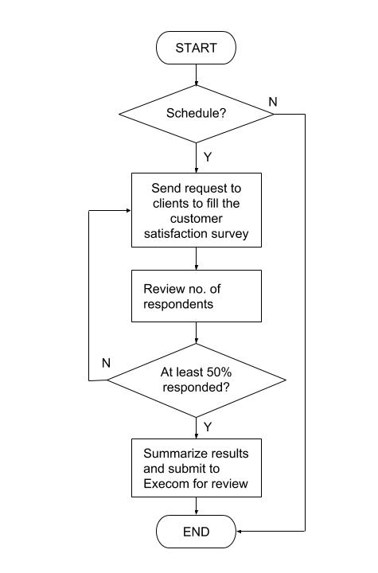 | Client Satisfaction Survey  ExeCom  Client Satisfaction Survey report  Minutes of review of the results of the client satisfaction survey

Notes:

1. Summary of the results of the Client Satisfaction Survey is reported on the next scheduled MMR.

- References
- Client Satisfaction Survey
- Results of the Client Satisfaction Survey
- Minutes of Review of the Results of the Client Satisfaction Survey

- Quality Records

- Client Satisfaction Survey
- Client Satisfaction Survey Report

